Chapter - 3

Even and Odd function

A function is called even if for all x in its domain. The graph of an even function is symmetric with respect to the y-axis. For example, any constant function, are even functions.

A function is called odd if for all x in its domain. The graph of an odd function is symmetric with respect to the origin. For example, are odd functions.

Most functions, however, are neither even nor odd.

Arithmetic Combinations of Even and Odd Functions

Operations | Even and Even | Odd and Odd | Even and Odd
+/- | Even | Odd | Neither
×/÷ | Even | Even | Odd

Calculus Properties of Even and Odd Functions

Suppose the function is an even function, continuous on, then

Suppose the function is an odd function, continuous on, then

Exercise 3.1
1. Determine the period of the following functions.

(a) $f\left(x\right)=\sin{5x}$, (b) $f\left(x\right)=tan{7x,}$ (c) ${f\left(x\right)=cos}^{2}{x,}$ (d) $f\left(x\right)=\sin^{2}{x-\cos^{2}{x}}$,
(e) $f\left(x\right)=\sin{2x+\cos{3x.}}$
(a) Ans:$\frac{2π}{5}.$ (b) Ans: $π/7.$ (c) Ans: $π.$ (d) Ans: $π.$ (e) Ans: $2π.$

2. Determine whether the following functions are even, odd or neither.

- $f\left(x\right)=\sin{x},$ (b) $f\left(x\right)=x^{3}-x,$ (c) $f\left(x\right)=\tan{x},$ (d) $f\left(x\right)=e^{x^{2}},$

(e) $f\left(x\right)=\cos{x, }$ (f) $f\left(x\right)=\frac{e^{3x}+e^{-3x}}{2},$ (g) $f\left(x\right)=\frac{e^{x}-e^{-x}}{2},$ (h)$f(x)=x^{3}$.

Periodic Function:

Let A function is said to be a periodic function if.
where is called period of f.

Example 01:
Describe the function shown in figure 1 with period 2 in two different ways:
1. By considering its values on the interval
2. By considering its values on the interval

Figure 1: A function of period 2

Solution:
1. On the interval, the function is a portion of the line thus if . The relation describes f(x) for all other values of x.
2. On the interval, the function consists of two lines. So we have

The relation describes f for all other values of x.

Example:

So, is periodic function and period.

Extension to an odd and even periodic function:

Let y=f (x) is function defined on 0 ≤ x ≤ L.

The odd extensions of f(x) are,

Figure 2: Graph of function f(x) and its odd extension

Similarly, the odd extension of any piecewise function is as follows:

Figure 3: Graph of piecewise function f(x) and its odd extension

The even extensions of f(x) are,

Figure 4: Graph of function f(x) and its even extension

Similarly, the even extension of any piecewise function is as follows:

Figure 5: Graph of piecewise function f(x) and its even extension
Example 02: Sketch the even extension of the function

Solution:
The even extension of the function is,
The sketch of the function and the even extension is,

Figure 6: Graph of function g(x) and its even extension
Example 03: Sketch the odd extension of the function

Solution:
The odd extension of the function is,
The sketch of the function and the odd extension are,

Figure 7: Graph of piecewise function g(x) and its odd extension

Some useful formulas:
$n∈Z.$

If is an odd number then $k∈Z$

and
Useful technique for integration by parts:
sign | Differentiation | Integration
+
-
+
- | 0

= = .

Full range Fourier series in Real form

The Fourier series is named in honor of Jean-Baptiste Joseph Fourier (1768–1830), who made important contributions to the study of trigonometric series. Fourier introduced the series for the purpose of solving the heat equation in a metal plate. In mathematics, it decomposes any periodic function or periodic signal into the weighted sum of a (possibly infinite) set of simple oscillating functions, namely sines/cosines and both (or, equivalently, complex exponentials). The fields of electronics, quantum mechanics, and electrodynamics all make heavy use of the Fourier series. Additionally, other methods based on the Fourier series, such as the FFT (Fast Fourier Transform – a form of a Discrete Fourier Transform [DFT]), are particularly useful for the fields of Digital Signal Processing (DSP).

Suppose f (x) is a periodic function with a period T = 2L or is defined on the interval (where L could be the length of a violin string or the length of a rod in heat conduction and so on). Then the Fourier series representation of f (x) is a trigonometric series (that is, it is an infinite series consists of sine and cosine terms) of the form,

where
and

The coefficients are called the Fourier coefficients of f (x).

Note that the cosine functions are even, while the sine functions are odd.

If f (x) is an even function then the integrand in (4) is odd, so for all n, leaving a Fourier cosine series (and perhaps a constant term) only for f (x).

If f (x) is an odd function then the integrand in (2) and (3) are odd, so for all n, leaving a Fourier sine series only for f (x).

Example 04:

Find a Fourier series for f (x) = x, −2 < x < 2, f (x + 4) = f (x).

Solution:

Figure 8: Graph of periodic function f(x)

Here, hence
sign | D | I
+
-
+
Again,

Now, we know the Fourier series of in the interval is

Therefore, the Fourier series for f (x) is

Figure 9: The graph of the partial sum of the first 30 terms of the above Fourier series

Example 05: Compute the first 4 components of the trigonometric Fourier series for the wave form below
.

Solution: From the figure we can construct the function as

Here, hence

Sign | D | I
+
- | -1
+

sign | D | I
+
- | -1
+

Therefore the Fourier series for f (x) is

Now, the first few partial sums in the Fourier series are
and so on.

The graphs of successive partial sums approach f (x) more closely.
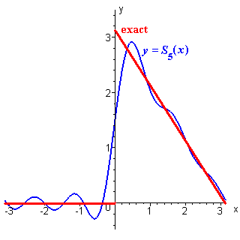
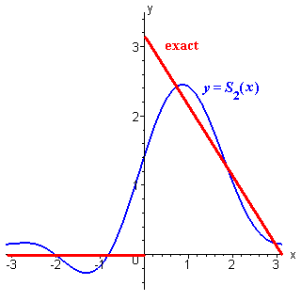

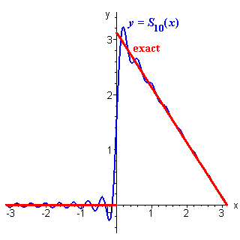
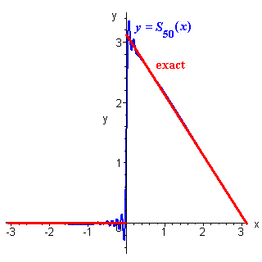

Figure 9: The graph of the partial sum of the first 50 terms of the above Fourier series

Example 06: Find the Fourier series expansion for the standard square wave,

Solution:

Figure 10: The graph of function f(x)

Here, hence

Therefore the Fourier series of f(x) is

The graphs of the third and ninth partial sums (containing two and five non-zero terms respectively) are displayed here, together with the exact form for f (x), with a periodic extension beyond the interval (–1, +1) that is appropriate for the square wave.

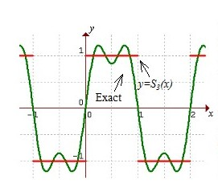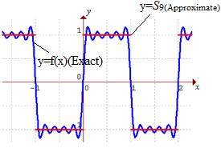

Figure 11: The graph of the partial sum of the first 9 terms of the above Fourier series

Example 07: Find the Fourier series for the function f (x) defined by
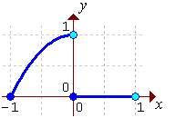
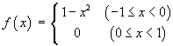

Solution:

Here, hence
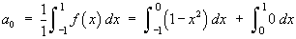

Figure 12: Graph of f(x)
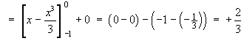
Sign | D | I
+
-
+
- | 0

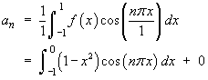

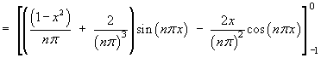
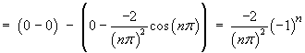
Sign | D | I
+
-
+
- | 0
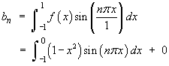

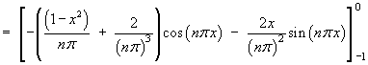
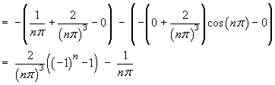
The Fourier series of f (x) on [–L, +L] in general is
Therefore
The first few terms of this series are
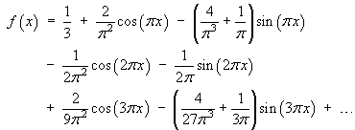
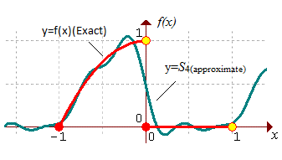
Figure 13: The graph of the partial sum of the first 4 terms of the above Fourier series

Example 08: Find the Fourier series for the function f (x) defined on the interval [–1, 1] by
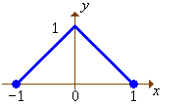

Solution:

Figure 14: The Graph of f(x)
Here,hence
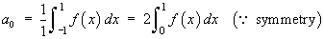
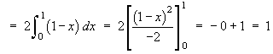
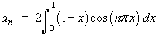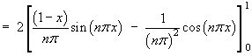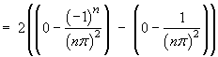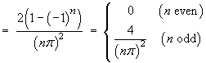 |  | Sign D I  +  -  +
Therefore the Fourier series is

The first few terms of this series are
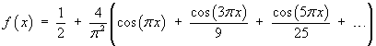

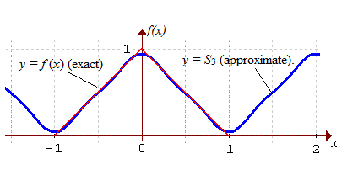

Figure 15: The graph of f(x) and the third partial sum S₃

Full range Fourier series in Complex form

Consider,$f(x)$ be defined in the interval,$[c-L,c+L$]. Fourier series of the function, $f(x)$ in real form:
If $f(x)$ be the periodic function of period 2L in the interval,$[c-L,c+L]$, Fourier series of the function, $f(x)$ in complex form can be written in the following form:
.
Here
The coefficient,is called complex Fourier coefficient. The complex form of Fourier series is algebraically simpler and more symmetric. Therefore, it is often used in physics and other sciences.

Example 09: Find the complex form of Fourier series of function, $f\left(x\right)=x^{2}$ in the region, $-π≤x≤π$.
Solution:
The Fourier series of function in complex form in the interval [c-L,c+L] is given by
.

Eq. (1) becomes,
This is the required complex form of Fourier series.

Exercise 3.2

- Sketch the graph and find the Fourier coefficients and then Fourier series of the function of in the interval
Ans: , ,
- Sketch the graph and find the Fourier coefficients and then Fourier series of the function of in the interval
Ans: , ,

- Sketch the graph and obtain the Fourier series of the function.
Ans: , , .

- Sketch the graph and obtain the Fourier series of the function in the interval $-π≤x≤π.$
Ans: , $a_{n}=\left\{\begin{aligned}\frac{-4}{πn^{2}} when n=1, 3, 5,… \\ 0 when n=2, 4, 6,…\end{aligned}\right.$ , .

- Find the complex form of Fourier series of the following function:
- $f\left(x\right)=2x$ in the region, $-π≤x≤π$.
- $f\left(x\right)=x^{2}$ in the region, $π≤x≤π$.
- $f\left(x\right)=x^{2}-x$ in the region, -$π≤x≤π.$

Half-Range Fourier series

If f(x) and f ′(x) are piecewise continuous functions defined on the interval 0 ≤ x ≤ L, then f(x) can be extended into an even periodic function, F, of period 2L, such that f (x) = F(x) on the interval [0, L], and whose Fourier series is, therefore, a cosine series.

Similarly, f(x) can be extended into an odd periodic function of period 2L, such that
f (x) = F(x) on the interval (0, L), and whose Fourier series is, therefore, a sine series.
The process that such extensions are obtained is often called cosine /sine series half-range expansions.
A Fourier series for f (x), valid on [0, L], may be constructed by extension of the domain to [–L, L].
An odd extension of f(x) of the period 2L leads to a Fourier sine series:
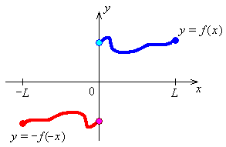
Figure 01: Odd extension of f(x)
where

An even extension of f(x) of period 2L leads to a Fourier cosine series:
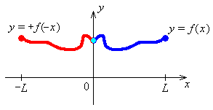
Figure 02: Even extension of f(x)
where, and
Example 01: Find the Half range Fourier sine and cosine series for

Solution:

Half range Fourier sine series (Odd periodic extension)
Sign | D | I
+
-
+
Figure 03: Odd extension of f(x)

Here, hence
An odd extension of f (x) is required to the interval [–1, 1].
a_{n} = 0 for all n.

Sign | D | I
+
-
+
Therefore the half range Fourier sine series for f (x) on [0, 1] (which is also the Fourier series for f (x) = x on

[–1, 1]) is

Half range Fourier cosine series (Even periodic extension)
Sign | D | I
+
-
+
Figure 04: Even extension of f(x)
Here, hence
An even extension of f (x) is required to the interval [–1, 1].
b_{n} = 0 for all n.
Sign | D | I
+
-
+

Therefore the half range Fourier cosine series for f (x) on [0, 1] (which is also the Fourier series for f (x) = x on [–1, 1]) is

Example 02: Find the first few terms of half range Fourier sine and cosine series for the wave form below

Solution:

From the figure we can construct the function as

Half range Fourier sine series (Odd periodic extension)

Figure 05: Odd extension of f(x)

Here, hence
An odd extension of f (x) is required to the interval [–1, 1].
a_{n} = 0 for all n.
Sign | D | I
+
-
+

Therefore the Fourier sine series for f (x) = x on [0, 1] (which is also the Fourier series for f (x) = x on [–1, 1]) is

Or

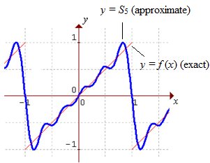
Figure 06: The graph of y=f(x) and the partial sum of the first 5 terms of the above Fourier series

Half range Fourier cosine series (Even periodic extension)

Figure 07: Even extension of f(x)

Here, hence
The even extension of f (x) is required to the interval [–1, 1].
b_{n} = 0 for all n.

Evaluating the Fourier cosine coefficients,
Sign | D | I
+
-
+

and

Evaluating the first few terms,
or

Therefore the Fourier cosine series for f (x) = x on [0, 1] (which is also the Fourier series for f (x) on [–1, 1] ) is
or

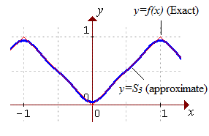
Figure 08: The graph of y=f(x) and the partial sum of the first 3 terms of the above Fourier series.
Example 03: Find the half range Fourier cosine series for the function f (x) defined on the interval [0, 2] by

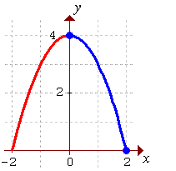
Solution:
Here,hence Figure 09: Even Extension of f(x)
An even extension of f (x) is required
b_{n} = 0 for all n.
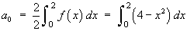
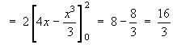
Sign | D | I
+
-
+
- | 0
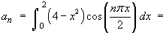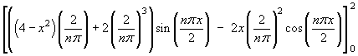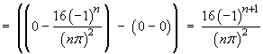

Therefore the Fourier series is

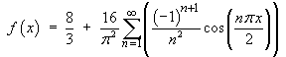
The first few terms of this series are
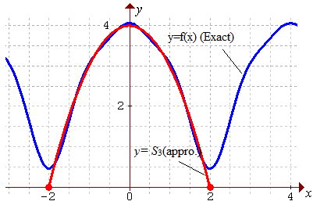
Figure 10: The graph of y=f(x) and the partial sum of the first 3 terms of the above Fourier series
Example 04: Find the half range Fourier sine series for the function f (x) defined on the interval [0, 2] by

Solution:
Here, henceAn odd extension of f (x) is required.
a_{n} = 0 for all n.
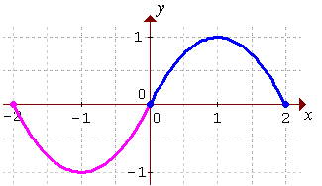
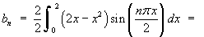
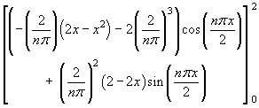

Figure 11: Odd extension of f(x)

Sign | D | I
+
-
+
- | 0
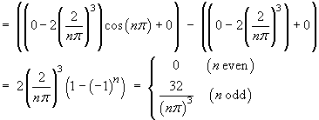

Therefore the Fourier series is
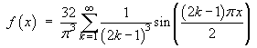

The first few terms of this series are
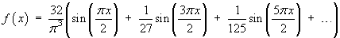

The partial sum of just the first three non-zero terms yields an excellent approximation everywhere. The graph of y=f(x) and the third partial sum y=S₃ illustrates:

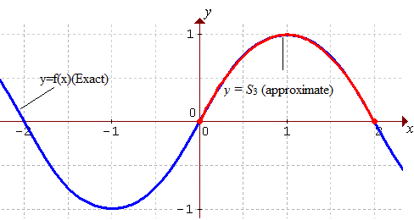
Figure 12: The graph of f(x) and the partial sum of the first 3 terms of the above Fourier series

Exercise: 3.3

- Sketch the odd and even extension and express as a half range Fourier sine and cosine series in the interval $0<x<2.$
- Sketch the odd and even extension and express $f\left(x\right)=x^{2}$as a half range Fourier sine and cosine series in the interval $0<x<π.$
$${Ans: f}_{s}\left(x\right)=\sum_{n=1}^{∞}{\frac{2}{π} \left[\frac{π^{2}}{n}{(-1)}^{n+1}+\frac{2}{n^{3}}\{{\left(-1\right)}^{n}-1\}\right]\sin{nx} }$$
$${ and f}_{c}\left(x\right)=\frac{π^{2}}{3}+\sum_{n=1}^{∞}{\frac{4}{n^{2}}{\left(-1\right)}^{n+1}\cos{nx.}}$$

- Sketch the odd and even extension and find the half range Fourier sine and cosine series of
$f\left(x\right)=\left\{\begin{aligned}x, 0<x<4 \\ 8-x, 4<x<8.\end{aligned}\right.$

Ans: $f_{s}\left(x\right)=\frac{32}{π^{2}} \sum_{n=1}^{∞}{\frac{1}{n^{2}}\sin{\frac{nπ}{2}}\sin{\frac{nπx}{8}}},$ and ${ f}_{c}\left(x\right)= \frac{16}{π^{2}}\sum_{n=1}^{∞}{[\frac{2cos{\frac{nπ}{2}}-\cos{nπ}-1}{n^{2}}}]\cos{\frac{nπx}{8}} .$

- Sketch the odd and even extension and find the half range Fourier sine and cosine series of
$$f\left(x\right)=\left\{\begin{aligned}1, 0<x<1 \\ 2, 1<x<2\end{aligned}\right..$$

Ans: $f_{s}\left(x\right)= \sum_{n=1}^{∞}{\left(\frac{2}{nπ}-\frac{4}{nπ}{\left(-1\right)}^{n}\right)\sin{\frac{nπx}{2}}}, f_{c}\left(x\right)= \frac{3}{2}-\sum_{n=1}^{∞}{\frac{2}{nπ}\sin{\frac{nπ}{2}}\cos{\frac{nπx}{2}}}.$
- Sketch and find the half range Fourier sine and cosine series of $f\left(x\right)= π-x$ in the interval $0<x<π.$
Ans: $f_{s}\left(x\right)=2\left[\frac{\sin{x}}{1}+ \frac{\sin{2x}}{2}+ \frac{\sin{3x}}{3}+…\right],$
and ${ f}_{c}\left(x\right)= \frac{π}{2}+ \frac{4}{π} \left[\frac{\cos{x}}{1^{2}}+ \frac{\cos{3x}}{3^{2}}+\frac{\cos{5x}}{5^{2}}+…\right].$

Fourier Integral

Fourier integral is a formula for the decomposition of a non-periodic function into harmonic components whose frequencies range over a continuous set of values.

Let f (x) is a periodic function with a period T = 2L or is defined on the interval Then the Fourier series representation of f (x) is a trigonometric series (that is, it is an infinite series consists of sine and cosine terms) of the form,

Note that,

As,
.
Hence, the Fourier integral of non-periodic function f(x) but piecewise continuous in any infinite interval as follows:

Where, and

Fourier cosine integral:
and
If the function f(x) is even then and writing,

(Even) and (odd)

Hence, the Fourier cosine integral of f(x) is

Fourier sine integral:
and
If the function f(x) is odd and writing then,
(odd) and(Even)

Hence, the Fourier sine integral of f(x) is

Note that:

Example: 01
Find the Fourier integral of where and hence prove that

Solution:

Here
Hence the Fourier integral of f(x) is,

Now,
(Proved)
Example: 02 Find the Fourier integral of the function

Solution:
Hence the Fourier integral of f(x) is,

Example: 03 Find the Fourier integral of the function
Solution: The Fourier integral of f(x) is,
where,
and
Hence the Fourier integral of f(x) is,

Example: 04

Find the Fourier sine integral of the function
.

Solution:
We know, for Fourier sine integral
Hence the Fourier sine integral of f(x) is,

Exercise: 3.4
- Find the Fourier integral of the function
$f\left(x\right)=\left\{\begin{aligned} 0 when x<-1 \\ 1-x when -1≤x≤1 . \\ 0 when x≥1 \end{aligned}\right.$

Ans: $f\left(x\right)=\frac{1}{π}\int_{0}^{∞}{\left[\frac{2}{πw}\sin{w\cos{wx+\frac{2}{π}\left(\frac{1}{w}\cos{w-}\frac{1}{w^{2}}\sin{w}\right)}}\sin{wx}\right]dw}.$
- Find the Fourier sine and cosine integral of the function

$f\left(x\right)=\left\{\begin{aligned}x^{2}, 0<x<2 \\ 0, x>2\end{aligned}\right.$.

- Find the Fourier integral of the function
$f\left(x\right)=\left\{\begin{aligned}0 when x<0 \\ \frac{1}{2} when x=0 . \\ e^{-x} when x>0\end{aligned}\right.$

Ans: $f\left(x\right)=\frac{1}{π}\int_{0}^{∞}{\frac{\cos{ux+u\sin{ux}}}{1+u^{2}}du}.$
- Find the Fourier integral of $f\left(x\right)=e^{-kx}$ when for

$k>0$and hence prove that .

- Find the Fourier integral of $f\left(x\right)=e^{-kx}$ when for

$k>0$and hence prove that .

Fourier Transform

The Fourier Transform is a generalization of the Fourier Series. Strictly speaking it only applies to continuous and aperiodic functions. The Fourier Transform converts a set of time domain data vectors into a set of frequency domain vectors. The Fourier transform is called the frequency domain representation of the original signal. The term Fourier transforms refers to both the frequency domain representation and the mathematical operation that associates the frequency domain representation to a function of time.

Finite Fourier sine transforms:

From half range Fourier sine series of in the interval
Where and is called finite Fourier sine transform.

From equation (1) ,we get
is called inverse finite Fourier sine transform of $F_{s}\left(f\left(x\right)\right)$.

Finite Fourier cosine transforms:

From half range Fourier cosine series of in the interval
Where and and is called finite Fourier cosine transform.

From equation (2), we get
is called inverse finite Fourier cosine transform of
Infinite Fourier sine transforms:

For an odd function, the Fourier integral is the Fourier sine integral
where

We now set Then from (4) writing we have
This is called infinite Fourier sine transform of . Similarly, from (3) we have,
This is called the inverse infinite Fourier sine transform of .

Infinite Fourier cosine transforms:

For an even function, the Fourier integral is the Fourier cosine integral
where

We now set Then from (4) writing we have
This is called infinite Fourier cosine transform of . Similarly, from (5) we have,

This is called the inverse infinite Fourier cosine transform of .

Example: 01
Find the Fourier sine transform of.
Solution: Here
We know the finite Fourier sine transforms of is
(Ans.)

Example: 02 Find the Fourier cosine transform of.

Solution: Here
We know the finite Fourier cosine transforms of is

Example 03: Find the Fourier sine and cosine transform of

Solution: We know the infinite Fourier sine transform is,
We know the infinite Fourier cosine transform is,

Exercise: 3.5

Sketch the graph and then find the (a) finite Fourier sine transform, and (b) finite Fourier cosine transform of the following functions:

- where $0<x<4.$
Ans: $f_{s}\left(n\right)=\frac{32}{nπ}{(-1)}^{n+1}, { f}_{c}\left(n\right)=\frac{32}{n^{2}π^{2}}{[(-1)}^{n}-1].$
- .
Ans: $f_{s}\left(n\right)=\left\{\begin{aligned}\frac{2b^{3}}{n^{3}π^{3}}\left(\cos{nπ}-1\right)-\frac{b^{3}}{nπ}\cos{nπ}, n=1,2,3,.. \\ \frac{b^{3}}{3}, n=0 \end{aligned}\right.$, ${ f}_{c}\left(n\right)=\frac{2b^{3}}{n^{2}π^{2}}\left(\cos{nπ}-1\right).$
- Sketch the graph and then find the (a) infinite Fourier sine transform, and (b) infinite Fourier cosine transform of .
Ans:
- Sketch the graph and then find the (a) infinite Fourier sine transform, and (b) infinite Fourier cosine transform of .
Ans: $f_{s}\left(n\right)=\sqrt{\frac{2}{π}}\frac{1}{n^{2}}(2\sin{w-\sin{2w}}), f_{c}\left(n\right)=\frac{1}{w^{2}} \sqrt{\frac{2}{π}} \left(2\cos{w}-\cos{2w-1}\right).$
- Sketch the graph and then find the (a) infinite Fourier sine transform, and (b) infinite Fourier cosine transform of $f\left(x\right)=e^{-x}, x≥0.$
Ans: $f_{s}\left(w\right)=\sqrt{\frac{2}{π}}\frac{w}{w^{2}+1}$ , $f_{c}\left(w\right)=\sqrt{\frac{2}{π}}\frac{1}{w^{2}+1}$ .

Reference:
W.H. Press et.al., Numerical Recipes in Fortran 90, Cambridge University Press 1996.
- Advance Engineering Mathematics, 10th edition by Erwin Kreyszig, Herbert Kreyszig, Edward J. Normintion.

